TITLE IN ENGLISH (Times New Roman 12 pt, bold, UPPERCASE except species name which should be written as usual e.g. Escherichia coli)

Author1,¹ Author2,² Author3^{3,}* (Times New Roman 12 pt; underline the presenter’s name and put a* (not superscript) after corresponding author’s name; use (full) Firstname Lastname format e.g. Tirayut Vilaivan – do not abbreviate initials.)

¹Affiliation of 1st author (Times New Roman 12 pt, include country name, without fullstop)
²Affiliation of 2nd author (No spacing before and after paragraph)
³Affiliation of 3rd author (Combine the affiliations that are shared by more than one authors.)
*e-mail: e-mail address of the corresponding author

Abstract Use Times New Roman 12 pt, symbols should be inserted by using menu Insert>Symbols (Font: Symbol 12 pt). The text should be fully justified.

Keywords: keyword1, keyword2, keyword3, keyword4, keyword5
(optional, up to 5 keywords, use lowercase letter except proper names)
Introduction A brief discussion of rationale and prior related work in the field.
Methodology Details of materials and methods, as well as experimental protocols if applicable.
Results Show the results. The figures and tables may be included, which should be numbered and referred to from the text.

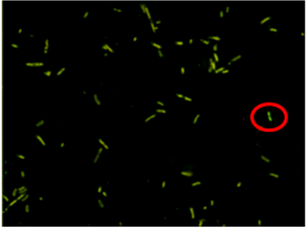 | 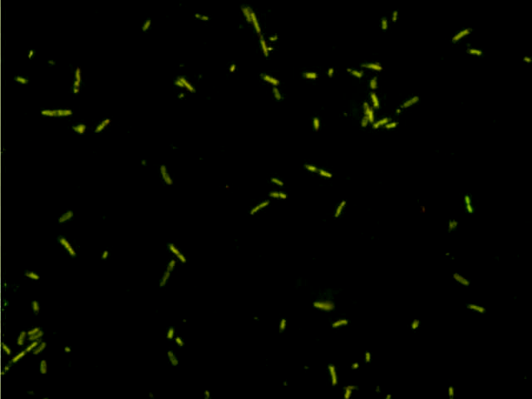

Figure 1 Examples of acceptable figure (left) and unacceptable figure (right)

Discussion and Conclusion
Acknowledgements (Optional, delete if not use.)
References
- Albrectsen BR, Bjorken L, Varad A, Hagner A, Wedin M, Karlsson J, Jansson S
(2010) Endophytic fungi in European aspen (Populus tremula) leaves diversity,
detection, and a suggested correlation with herbivory resistance. Fungal Divers
41:17–28.
All references must be author-year and left-justified. Use only the standard format shown above. Web pages and books should not be used as references. Use autonumber feature in MS Word to adjust the indentation of references.

Details of template setting:
Page Layout A4, portrait, 1" margins
Font Times New Roman 12 pt, for Symbols use menu Insert>Symbol (Font: Symbol 12 pt)
Paragraph Style Single line spacing and fully justified, except for title, authors and affiliations, which should be left-justified.
Other The maximum length of full paper is 10 pages.

COMMUNITY COMPOSITION OF ENDOPHYTIC FUNGI IN Acer truncatum AND THEIR ROLE IN ECOMPOSITION

Xiang Sun¹, Liang-Dong Guo^{1,*}and Kevin. D. Hyde²

¹Key Laboratory of Systematic Mycology & Lichenology, Institute of Microbiology, Chinese
Academy of Sciences, Beijing 100190, People’s Republic of China
²School of Science, Mae Fah Luang University, Thasud, Chiang Rai 57100, Thailand
*e-mail guold@im.ac.cn

Abstract
The mycota and decomposing potential of endophytic fungi associated with Acer truncatum, a common tree in northern China, were investigated. The colonization rate of endophytic fungi was significantly higher in twigs (77%) than in leaves (11%). However, there was no significant difference in the colonization rates of endophytic fungi between lamina (9%) and midrib (14%) tissues. A total of 58 endophytic taxa were recovered using two isolation methods and these were identified based on morphology and ITS sequence data. High numbers of leaf endophytes were obtained in the method to determine decomposition of leaves by the natural endophyte community (35 taxa) as compared to disk fragment methodology (9 taxa). The weight loss in A. truncatum leaves decomposed by endophyte communities increased with incubation time; the weight loss was significantly higher at 20 weeks than at 3 and 8 weeks. Both common and rare endophytic taxa produced extracellular enzymes in vitro and showed different leaf decay abilities. Our results indicated that the composition and diversity of endophytic fungi obtained differed using two isolation methods. This study suggests that endophytic fungi play an important role in recycling of nutrients in natural ecosystems.

Keywords: endophyte, isolation method, leaf decomposition, extracellular enzymes

Introduction
Endophytic fungi have been associated with plants for over 400 million years (Krings et al. 2007) and have been isolated from many different plants such as mosses (Jakucs et al. 2003; Davey and Currah 2006), ferns (Swatzell et al. 1996), grasses (Muller and Krauss 2005; Su et al. 2010), shrub plants (Barrow et al. 2004; Olsrud et al. 2007), deciduous and coniferous trees (Guo et al. 2008; Albrectsen et al. 2010; Mohamed et al. 2010), and lichens (Suryanarayanan et al.2005; Li et al. 2007). Because of the high diversity of endophytic fungi (Arnold and Lutzoni 2007; Hyde and Soytong 2007, 2008), their ability to produce various bioactive chemicals (Aly et al. 2010; Xu et al. 2010) and promotion of host growth and resistance (Cheplick et al.1989; Ting et al. 2008; Saikkonen et al. 2010), the study of endophyte has become one of the hottest research focuses in mycology.

Methodology
Sampling site
The study was carried out in the Dongling mountain mixed woodland of the Forest Ecosystem Research Station of the Chinese Academy of Sciences, located 117 km west of Beijing, China (39º58′N, 115º26′E). The warm temperate sampling site is located at an altitude of 1211 ma.s.l. The mean annual temperature is 4.8 C, and the mean annual precipitation is 611.9 mm.

Data analysis
Colonization rates (CR) were calculated as the total number of plant tissue fragments infected by one or more fungi divided by the total number fragments incubated (Kumar and Hyde 2004). Relative frequency (RF) was calculated as the number of isolates of certain species divided by the total number of isolates. Endophytes were categorized as common taxa when RF≥1% and as rare taxa when RF<1%, as in previous endophyte studies (Guo et al. 2008; Sunet al. 2008).

Results
Colonization rates of endophytic fungi.

A total of 465 endophyte strains were isolated from 800 plant tissue fragments of Acer truncatum using disk fragment methodology. Of these strains, 418 were recovered from branches and 47 from leaves (Table 1). The overall colonization rate of endophytic fungi in samples was 50%. The colonization rate of endophytic fungi was significantly higher in twigs (77%) than in leaves (11%). However, there was no significant difference of the colonization rates of endophytic fungi between lamina (9%) and midrib (14%) tissues. The colonization rates of endophytic fungi were significantly lower in 1 year old

Table 1 Colonization rates of endophytic fungi in leaves and twigs of Acer truncatum
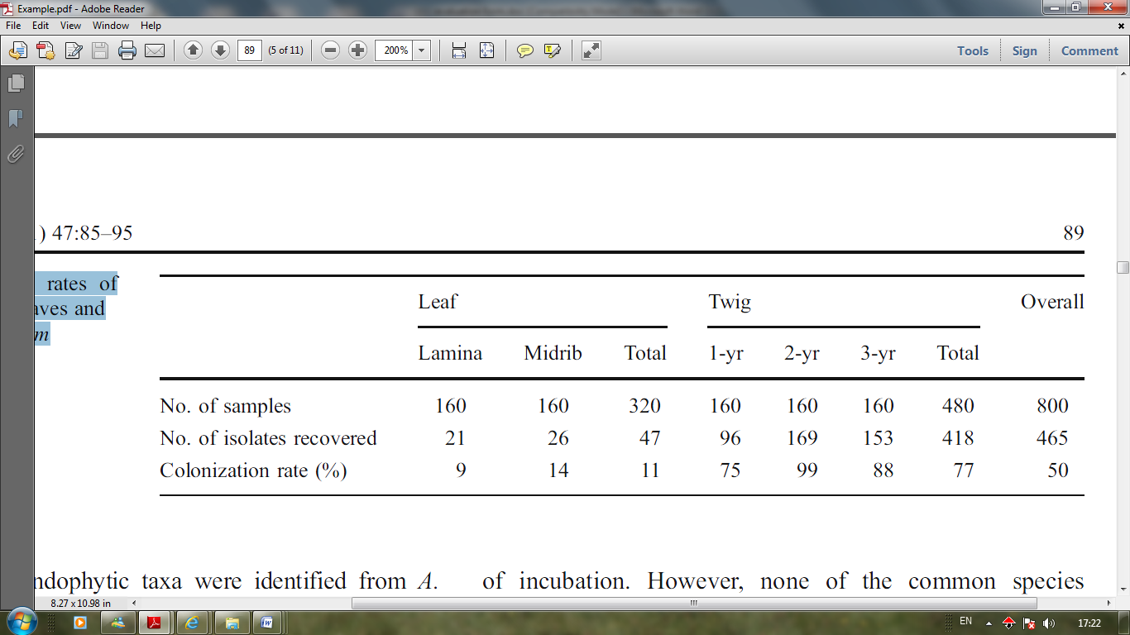

Discussion and Conclusion
Effect of isolation and identification methods on endophytic diversity.

It is unlikely that the entire endophyte diversity can be revealed using single isolation techniques (Hyde and Soytong 2007, 2008). In the present study, nine endophytic taxa were isolated using disk fragment methodology, but 35 taxa were isolated using the method to determine decomposition of leaves by the natural endophyte community. This confirms that the entire endophyte community cannot be revealed by a single technique. The endophytic taxa isolated are affected by the size of incubated plant fragments when traditional methodology is applied. Gamboa et al. (2003) reported that the number of endophytes isolated was strongly correlated linearly with the size of fragments. Unterseher and Schnittler (2009) acquired complementary endophyte compositions when applying fragment plating and extinction culturing, in which about two-thirds of the 35 fungal taxa were isolated using one cultivation technique. Isolation of endophytes would be also affected by the fitness of media and the growth rate of strains (Fisher and Petrini 1987; Bills 1996). Thus, it is unlikely that the investigator would acquire the entire endophyte community using a single isolation technique (Gamboa et al. 2003; Schulz and Boyle 2005).

In general, the common species had a higher decomposing ability than the rare species, based on the results obtained in the present study. All nine common species caused more than 25% weight loss after 16 weeks of incubation, whereas only four of the twelve rare species did so. We hypothesize that a saprobic lifestyle may be characteristic of the common species, while the rare species may be less efficient decomposers producing less propagules and therefore becoming less common endophytes. It would be worthwhile to study the ecological roles and interaction between host of common and rare species in ecosystems, and to establish the evolutionary relationships of common and rare species in future work.

Acknowledgements
This project is supported by the National Natural Science Foundation of China Grants (No. 30930005 and 30870087) and the Chinese Academy of Sciences Grant (No. KSCX2-YW-Z-0935).

References
1. Albrectsen BR, Bjorken L, Varad A, Hagner A, Wedin M, Karlsson J, Jansson S
(2010) Endophytic fungi in European aspen (Populus tremula) leaves diversity,
detection, and a suggested correlation with herbivory resistance. Fungal Divers
41:17–28.
- Aly AH, Debbab A, Kjer J, Proksch P (2010) Fungal endophytes from higher plants: a
prolific source of phytochemicals and other bioactive natural products. Fungal Divers
41:1–16.
- Arnold AE, Lutzoni F (2007) Diversity and host range of foliar fungal endophytes: are tropical leaves biodiversity hotspots? Ecology 88:541–549.
- Barrow JR, Osuna-Avila P, Reyes-Vera I (2004) Fungal endophytes intrinsically associated with micropropagated plants regenerated from native Bouteloua eriopoda Torr. and Atriplex canescens (Pursh) Nutt. In Vitro Cell Dev Biol—Plant 40:608–612.
- Collado J, Platas G, Pelaez F (2000) Host specificity in fungal endophytic populations of Quercus ilex and Quercus faginea from Central Spain. Nova Hedwig 71:421–430.

